**Handwriting Recognition**

**COURSE PROJECT REPORT**

**18CSE398J -Machine Learning - Core Concepts with Applications**

**(2018 Regulation)**

**III Year/ VI Semester**

**Academic Year: 2022 -2023 (EVEN)**

By

**Adrija Mukherjee - RA2011033010020**

**Lawrence Swaminathan**

**Vignesh Pradhan**

Under the guidance of

**Dr. Vijayalakshmi V**

**Assistant Professor**

**Department of Data Science and Business Systems**



**DEPARTMENT OF DATA SCIENCE AND BUSINESS SYSTEMS**

**FACULTY OF ENGINEERING AND TECHNOLOGY**

**SRM INSTITUTE OF SCIENCE AND TECHNOLOGY**

**Kattankulathur, Kancheepuram**

**MAY 2023**

**Table of Contents**

|  |  |  |
| --- | --- | --- |
| **Serial No.** | **Topic** | **Page Number** |
| 1 | Abstract | 3 |
| 2 | Introduction | 4 |
| 3 | About the Dataset | 5 |
| 4 | Methods to create the Model | 6 |
| 5 | About the Algorithm | 7 |
| 6 | Code | 8 |
| 7 | Conclusion | 11 |
| 8 | Future Work | 12 |
| 9 | References | 13 |

**Abstract**

As the name suggests, the handwritten Character recognition is the ability of computers to recognize human handwritten characters. Or in easy words we can say that it is the ability of computers to detect the character present in a particular image and recognize that character.By leveraging the power of advanced algorithms and large datasets, ML is poised to help us better understand the underlying mechanisms of handwriting recognition.

Developers are putting all their strength to make machines more intelligent, and smarter than humans. Deep learning is one such technique that contributes to developers enhancing machines. To memorize how a task is performed, what do humans do? Humans keep practicing and repeating that task again and again so that they get proficient in that task. After some time our brain neurons can automatically trigger and perform the task quickly and accurately. Likewise, deep learning follows the approach to solving a problem. Various types of neural network architectures are used by deep learning algorithms to solve different types of problems.

**Introduction**

Handwriting recognition (HWR), also known as handwritten text recognition (HTR), is the ability of a computer to receive and interpret intelligible [handwritten](https://en.wikipedia.org/wiki/Handwriting" \o "Handwriting) input from sources such as [paper](https://en.wikipedia.org/wiki/Paper" \o "Paper) documents, [photographs](https://en.wikipedia.org/wiki/Photograph" \o "Photograph), [touch-screens](https://en.wikipedia.org/wiki/Touch-screen" \o "Touch-screen) and other devices.[[1]](https://en.wikipedia.org/wiki/Handwriting_recognition" \l "cite_note-1)[[2]](https://en.wikipedia.org/wiki/Handwriting_recognition" \l "cite_note-2) The image of the written text may be sensed "off line" from a piece of paper by optical scanning ([optical character recognition](https://en.wikipedia.org/wiki/Optical_character_recognition" \o "Optical character recognition)) or [intelligent word recognition](https://en.wikipedia.org/wiki/Intelligent_word_recognition" \o "Intelligent word recognition). Alternatively, the movements of the pen tip may be sensed "on line", for example by a pen-based computer screen surface, a generally easier task as there are more clues available. A handwriting recognition system handles formatting, performs correct [segmentation](https://en.wikipedia.org/wiki/Segment_(handwriting)" \o "Segment (handwriting)) into characters, and finds the most plausible words.

[Feature extraction](https://en.wikipedia.org/wiki/Feature_extraction" \o "Feature extraction) works in a similar fashion to neural network recognizers. However, programmers must manually determine the properties they feel are important. This approach gives the recognizer more control over the properties used in identification. Yet any system using this approach requires substantially more development time than a neural network because the properties are not learned automatically.

**About the Dataset**

We will be using a Dataset given by sachin patel. The name of this dataset is A-Z Handwritten Alphabets in.csv file. This dataset is basically a csv file which contains 372450 images of alphabets of 28×28 size

This dataset can be utilized to develop machine learning models to recognize handwriitng based on the input parameters.

. EMNIST dataset which consists of English alphabets and numbers are made useof to train the neural network.

EMNIST balanced dataset consist of 131,600images of characters and 47 classes .The feature extraction technique is obtainedby normalizing the pixel values. Pixel values will range from 0 to 255 whichrepresents the intensity of each pixel in the image and they are normalized torepresent value between 0 and 1.

Convolutional neural network is used as aclassifier which trains the EMNIST dataset. The work is extended by adding somemore dataset to EMNIST dataset of characters from Tamil language and trainingthe model. The prediction for the given input image is obtained from the trainedclassifier.

**Method To Create the Model**

* Data Cleaning and Preprocessing: The first step in the implementation process would be to clean and preprocess the dataset. This involves removing any missing or duplicate values, converting categorical variables into numerical values, and scaling the data.
* Feature Selection: The next step would be to select the most relevant features that can help in predicting the type of tumor. This can be achieved using statistical methods such as correlation analysis or machine learning-based feature selection algorithms.
* Model Selection: Once the features have been selected, the next step would be to choose an appropriate machine learning model that can recognzie handwriting. For image recognition and processing, there is a very popular artificial neural network used that is Convolutional neural network (CNN) that is specifically designed to process pixel data. And that’s why we are going to build a CNN model to recognise character.
* Model Training: After selecting the model, the next step would be to train the model on the dataset. This involves dividing the data into training and testing sets, tuning the model's hyperparameters, and optimizing the model's performance.
* Model Evaluation: Once the model has been trained, the next step would be to evaluate its performance using various metrics such as accuracy, precision, recall, and F1-score. This can help determine if the model is performing well or needs further improvement.
* Deployment: After evaluating the model's performance, the final step would be to deploy the model in a real-world setting. This can involve integrating the model with an existing healthcare system or developing a new software application for cancer diagnosis.
* Continuous Improvement: Finally, the implementation process should include a continuous improvement phase, where the model's performance is monitored, and the model is updated periodically to incorporate new data and improve its accuracy.

**About the Algorithm**

The various modules of the proposed system includes Pre-processing, Feature Extraction, MinMaxScaler -fitting of data, Image normalization and Classification.

1. PRE-PROCESSING : Pre-processing of input image is carried out by converting the given image into gray-scale image. Usually a normal colored image consist of three channels- red channel, green channel, blue channel commonly known as RGB. Then the coloured image is converted it to gray-scale image which consist of single monochrome channel in order to avoid unwanted noise in the image. The given input image would be of varied size which may be lead to loss of accurate prediction when the image is compared with that of trained convolutional neural network. So the image is resized and placed upon a empty 28 x 28 pixel blank image so that the image resolution matches the resolution of EMNIST dataset.
2. FEATURE EXTRACTION : Feature extraction is the process of transforming the input data into a set of features which can very well represent the input data. Feature extraction is related to dimensionality reduction. When the input data is too large to be processed, then it can be transformed into a reduced set of features (also named a feature vector). Determining a subset of the initial features is called feature selection. The selected features are expected to contain the relevant information from the input data, so that the desired task can be performed by using this reduced representation instead of the complete initial data.After resizing the image, pixel values are obtained in the form of 1D array which represents values between 255 and 0 based on pixel intensity.
3. MIN MAX SCALER : The min-max scalar form of normalization uses the mean and standard deviation to box all the data into a range lying between a certain min and max value. It transforms features by scaling each feature to a given range. This estimator scales and translates each feature individually such that it is in the given range on the training set, i.e. between zero and one. This transformation is often used as an alternative to zero mean, unit variance scaling. It essentially shrinks the range such that the range is now between 0 and 1 (or -1 to 1 if there are negative values). The MinMaxScaler is the probably the most famous scaling algorithm, and follows the following formula for each feature: (xi–min(x))/ (max(x)–min(x) )
4. IMAGE NORMALIZATION : Normalization is a process that changes the range of pixel intensity values. Normalization is sometimes called contrast stretching or histogram stretching. In this input image the normalization is carried out by removing the background pixels and the character alone will be provided as it is in the image. This can be done by using a random value so that the background pixels will have a value certainly less than the pixel values of shades of the character. In this way the image is normalized such that the image is similar to the values in the EMNIST dataset. In this image, the pixel values are more than 0 for the region where the character ‘A’ is written and all other regions have pixel values 0 after image normalization.

E. CLASSIFICATION : Convolutional neural network is used as a classifier for classifying the handwritten character from the input image. A CNN consists of an input and an output layer, as well as multiple hidden layers. The hidden layers of a CNN typically consist of convolutional layers, pooling layers, fully connected layers and normalization layers. A CNN consists of three major components which are convolutional layer, pooling layer and output layer. The activation function that is commonly used with CNN is ReLU which stands for Rectified Linear Unit. Convolution layer will compute the output of neurons that are connected to local regions in the input, each computing a dot product between their weights and a small region they are connected to in the input volume. The pooling layer is a form of nonlinear down-sampling. Max pooling is the most common which partition the input image into a set of non-overlapping rectangles and, for each such sub-region, outputs the maximum. ReLU applies the non-saturating activation function . It increases the nonlinear properties of the decision function and of the overall network without affecting the receptive fields of the convolution layer. A rectified linear unit has output 0 if the input is less than 0, and raw output otherwise. Its value is obtained based on the formula which is as follows: f(x)= max(x,0) The softmax function is often used in the final layer of a neural network-based classifier. The softmax function squashes the outputs of each unit to be between 0 and 1, just like a sigmoid function. But it also divides each output such that the total sum of the outputs is equal to 1. The output of the softmax function is equivalent to a categorical probability distribution. Thus, softmax function calculates the probabilities distribution of the event over ‘n’ different events.

**Code**

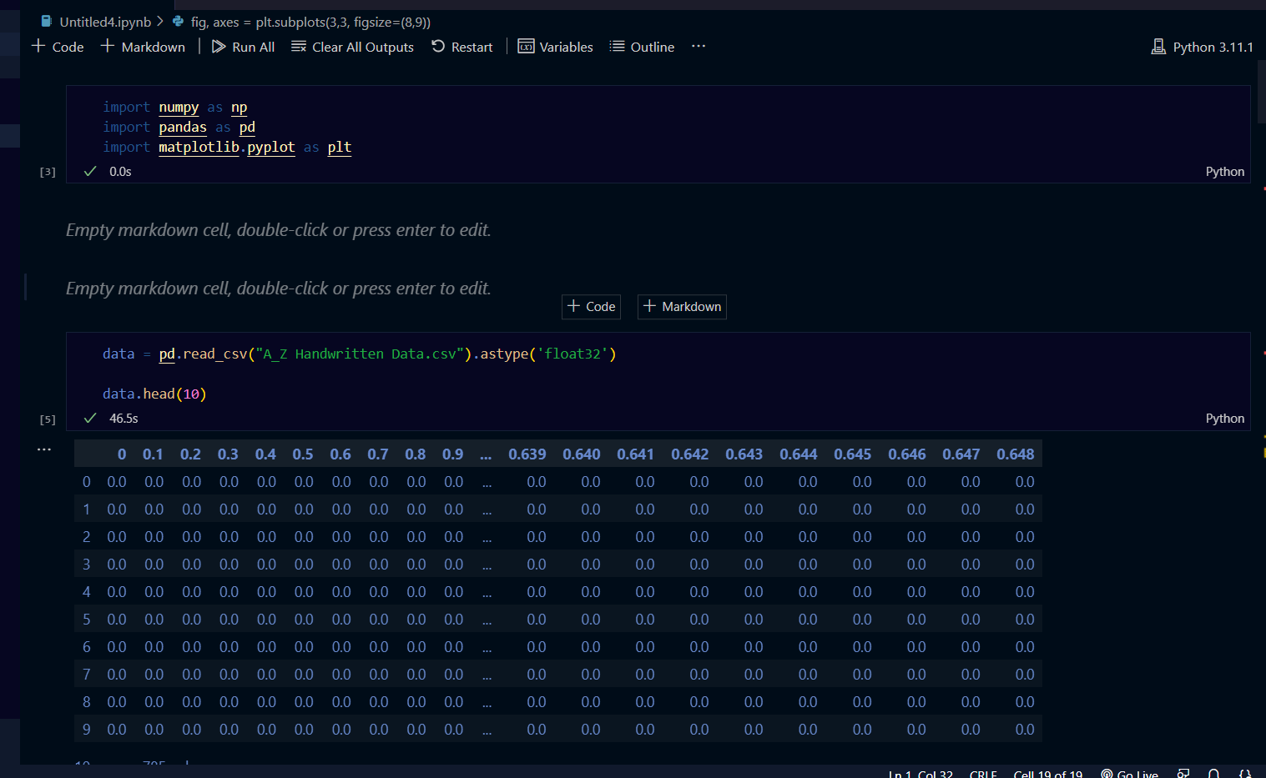

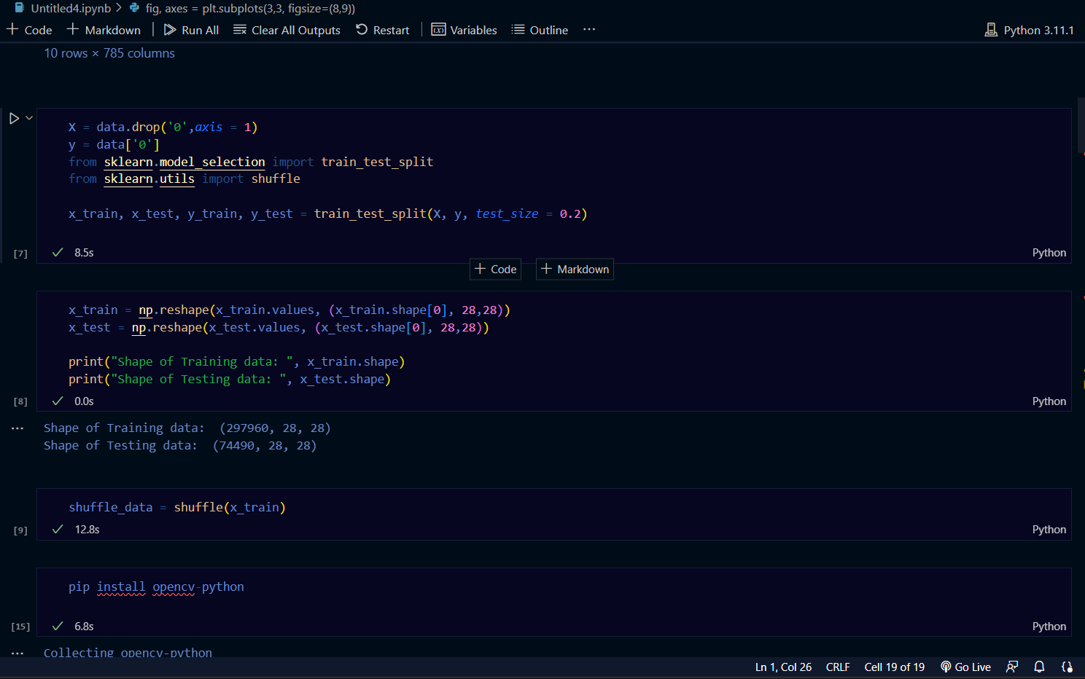

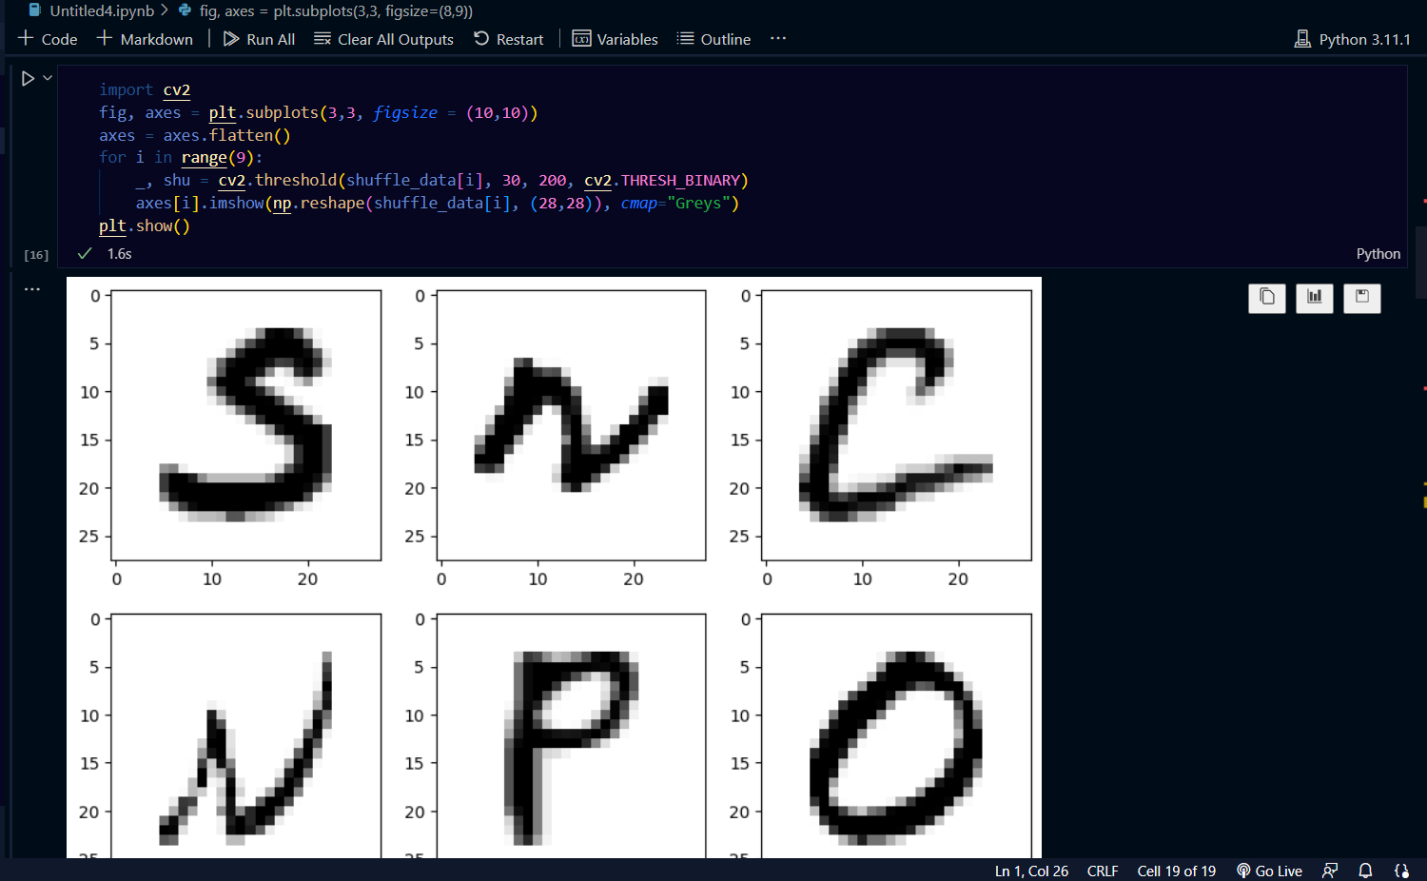

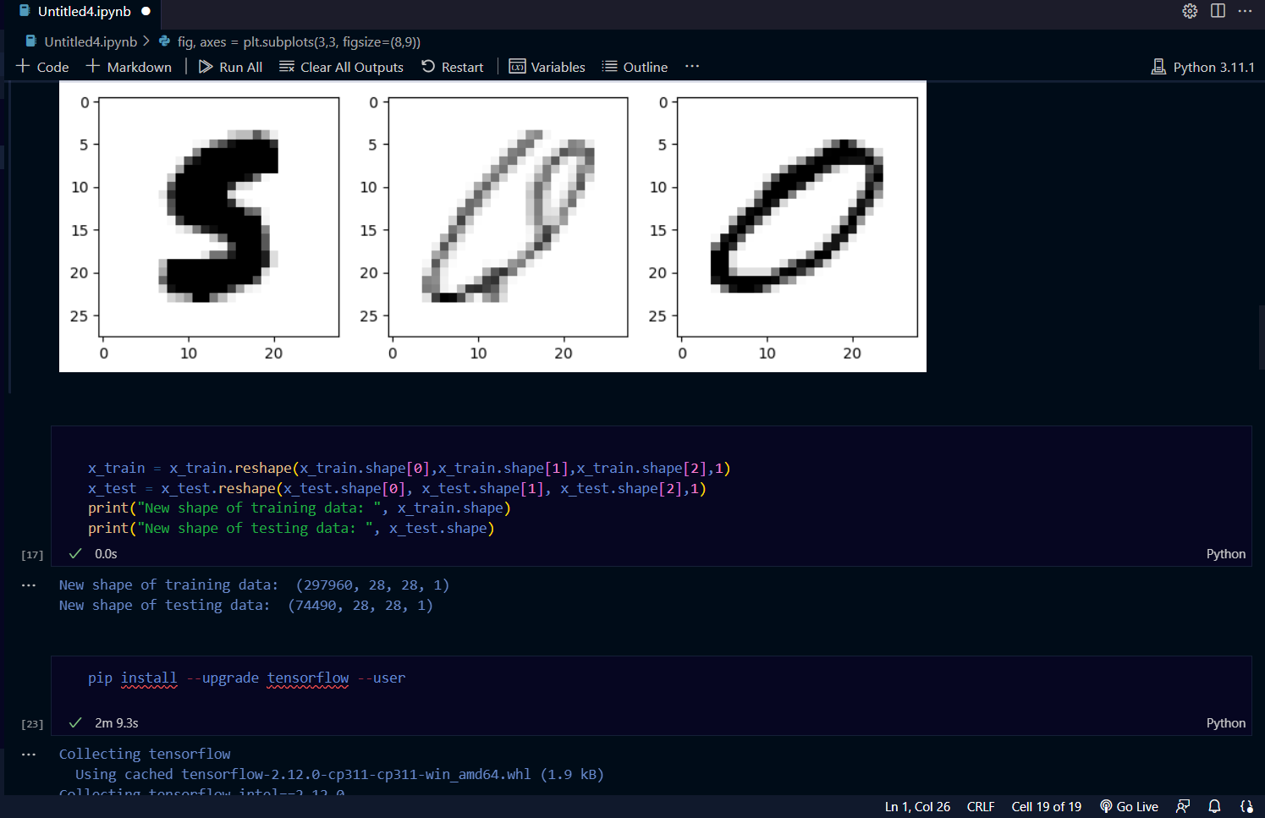

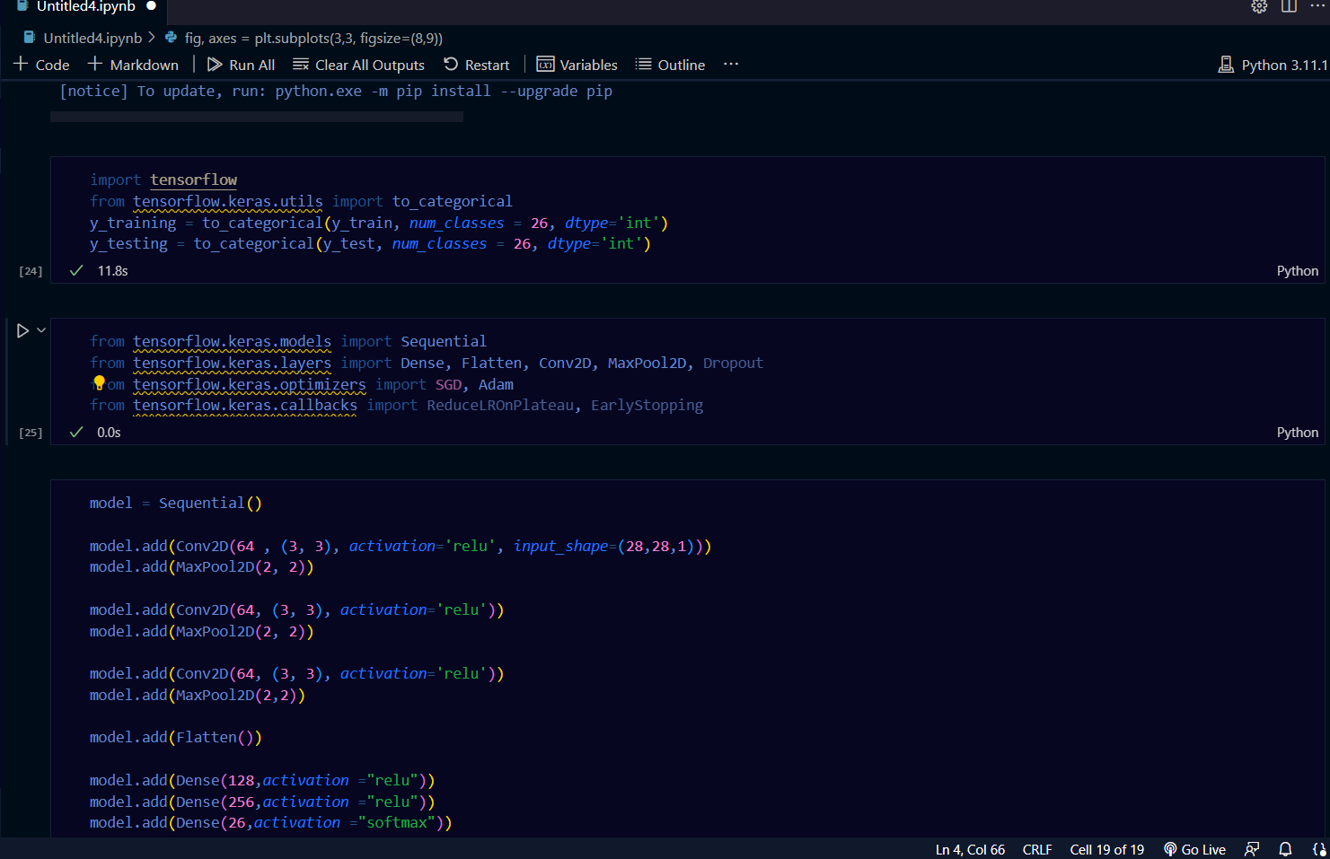

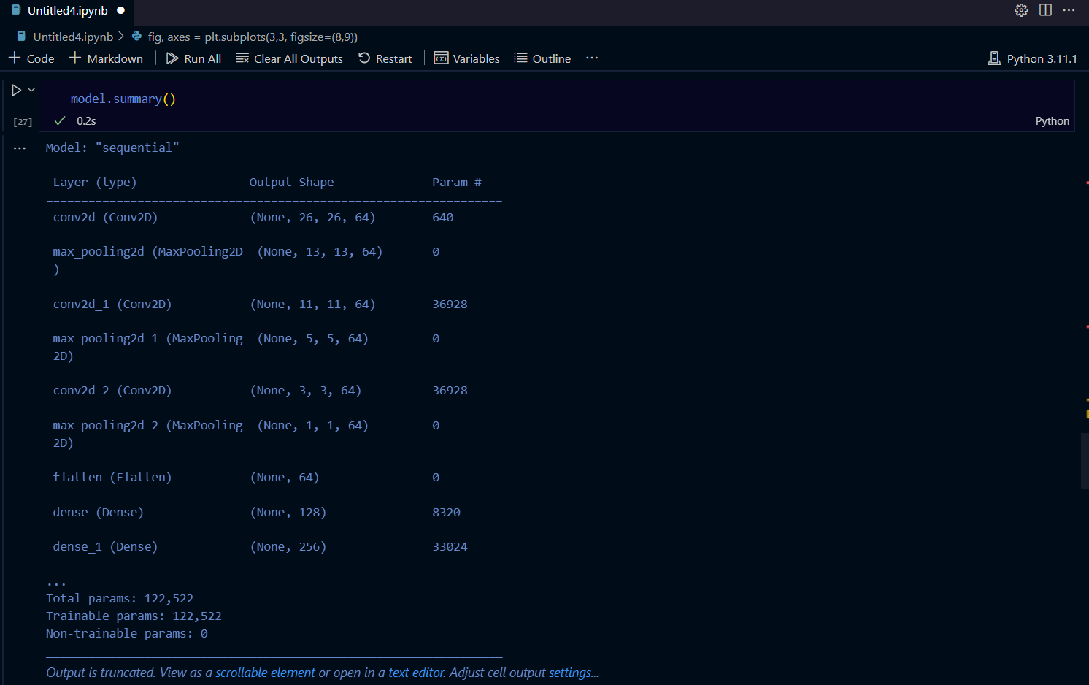

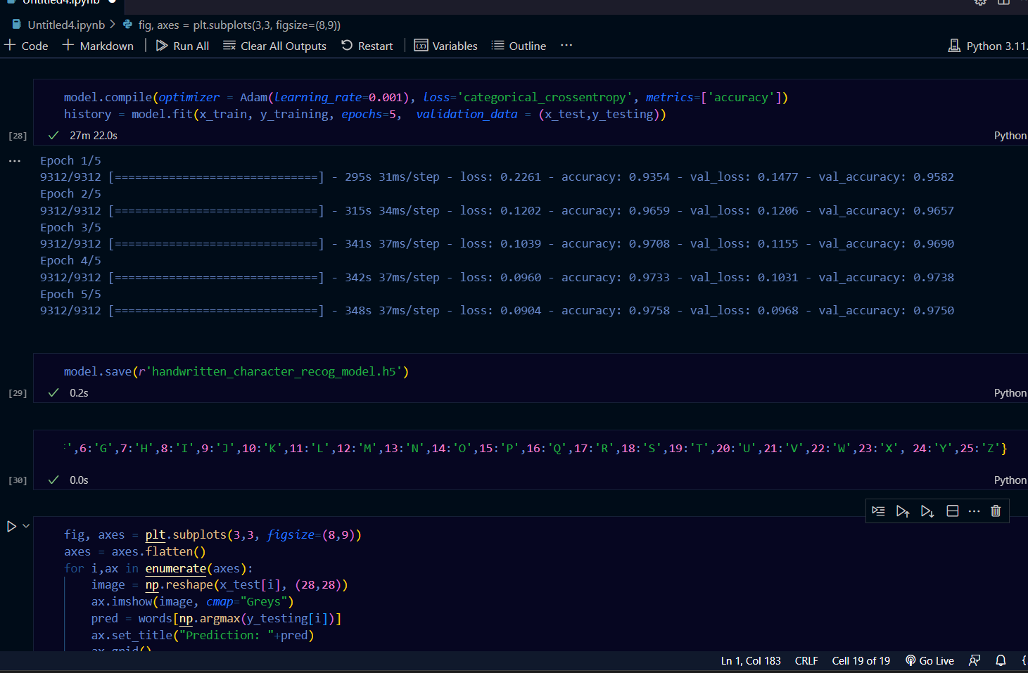

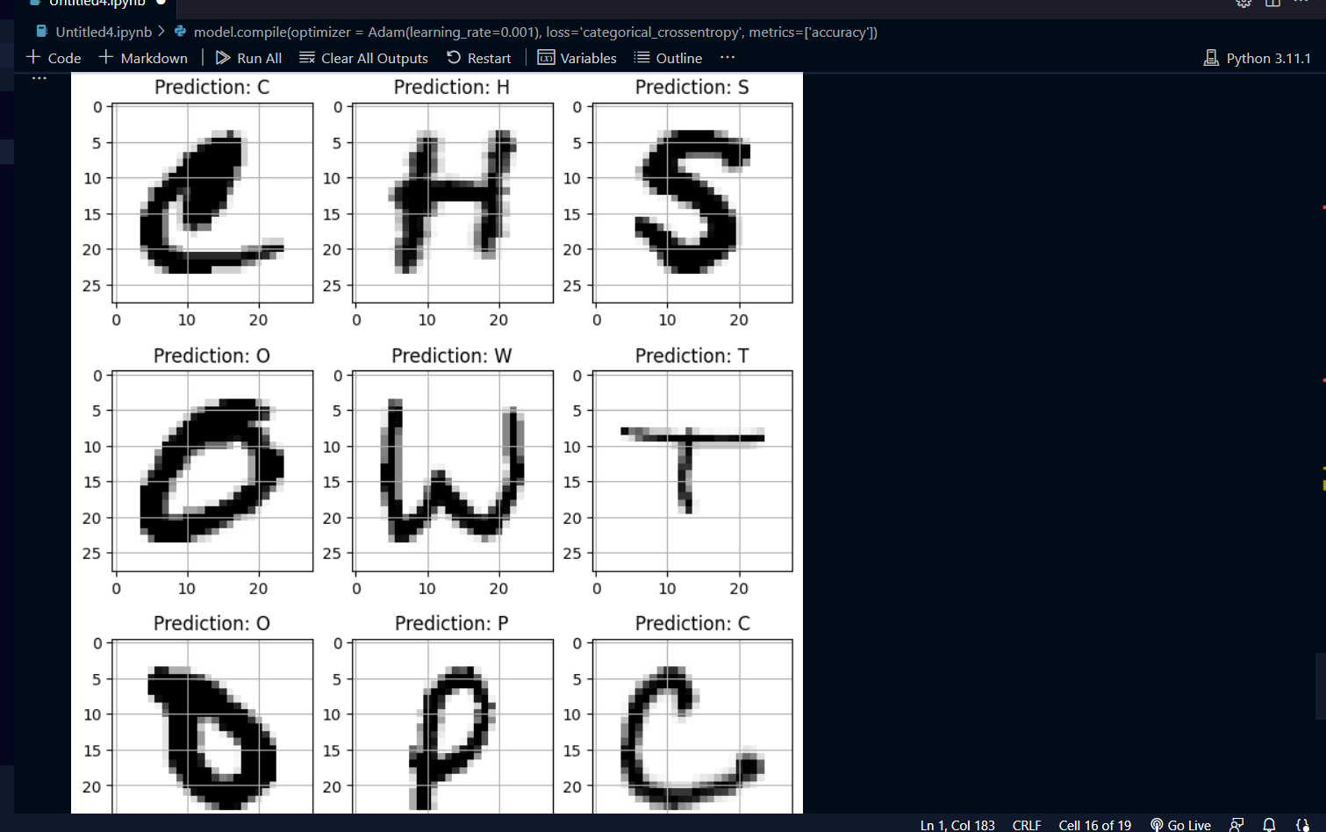

**Conclusions**

* The machine learning model developed using the alphabet data set can accurately predict letters from handwritng.
* The model's performance can be further improved by incorporating additional features or by using more advanced machine learning algorithms.
* In the future, it will be important to validate our model on larger and more diverse datasets, and to explore the potential of machine learning in other areas of cancer research and treatment.
* Our findings have important implications for image recognition, as our model can accurately recognize letters from given pictures

**Future Work**

* It is possible to explore the use of more advanced machine learning techniques such as deep learning or ensemble models to improve the accuracy of the predictions.
* The proposed system takes 28x28 pixel sized images as input. The same system with further modifications and improvements in the dataset and the model can be used to build Handwritten Character Recognition System which recognizes human handwritten characters and predicts the output.
* Finally, it is important to continuously monitor the model's performance and update it periodically to reflect new data and changes in patient demographics or risk factors.
* While our study focused on a limited set of features, there are likely many other factors that could improve the accuracy of our model. For example, incorporating genetic or molecular markers could provideWhile machine learning models can be highly accurate, they are often considered "black boxes" that are difficult to interpret. In the future, it will be important to develop methods for improving the interpretability of our models, such as by identifying the most important features or providing explanations for model predictions.

**References**

1. https://medium.com/the-andela-way/applying-machine-learning-to-recognize handwrittencharacters-babcd4b8d70
2. .Scikit Learn Documentation (https://scikit-learn.org/stable/index.html)
3. Matplotlib- Visualisation with Python (https://matplotlib.org/)

4.Handwritten Digit Recognition System using Machine Learning in Python (ANIL NEERUKONDA INSTITUTE OF TECHNOLOGY AND SCIENCES

5. Machine Learning with Python (https://www.geeksforgeeks.org/machine-learning-with-python/)

6. Python Machine Learning Course (https://www.youtube.com/watch?v=7eh4d6sabA0)

7.PyImage Machine Learning (https://pyimagesearch.com/2019/01/14/machine-learning-in-python/)

8.<https://www.reddit.com/r/cbirt/comments/1206v7u/machine_learningaided_multiscale_transcriptomics/>

9.<https://link.springer.com/article/10.1007/s00259-023-06145-z>